Testing and bug fixing
Test area | What to test | Evidence required
Start/opening test | Does the game open/start correctly? YES | 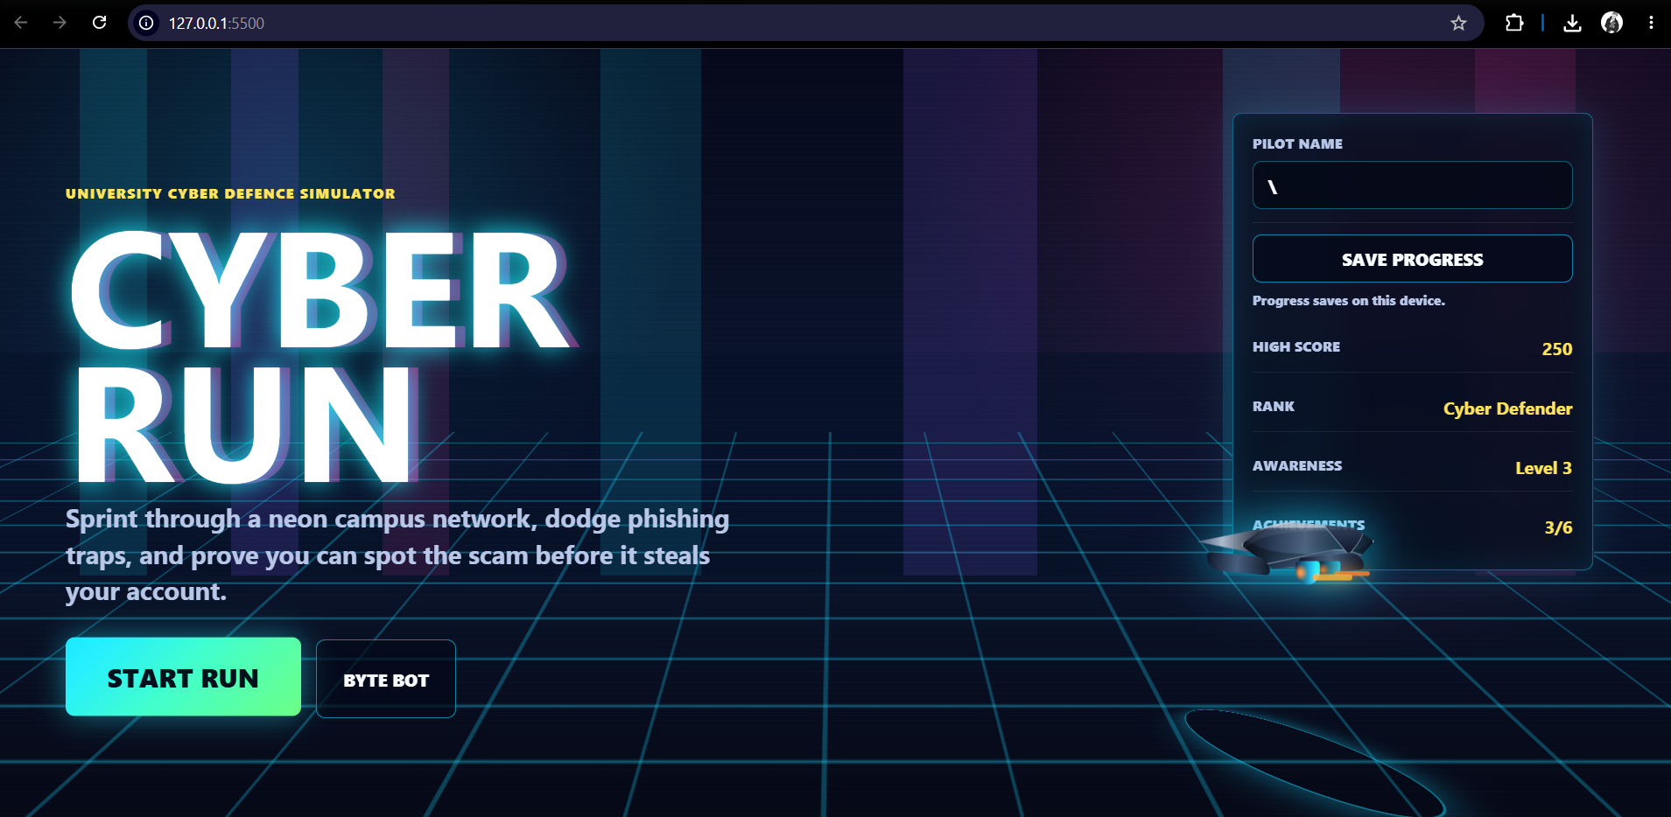  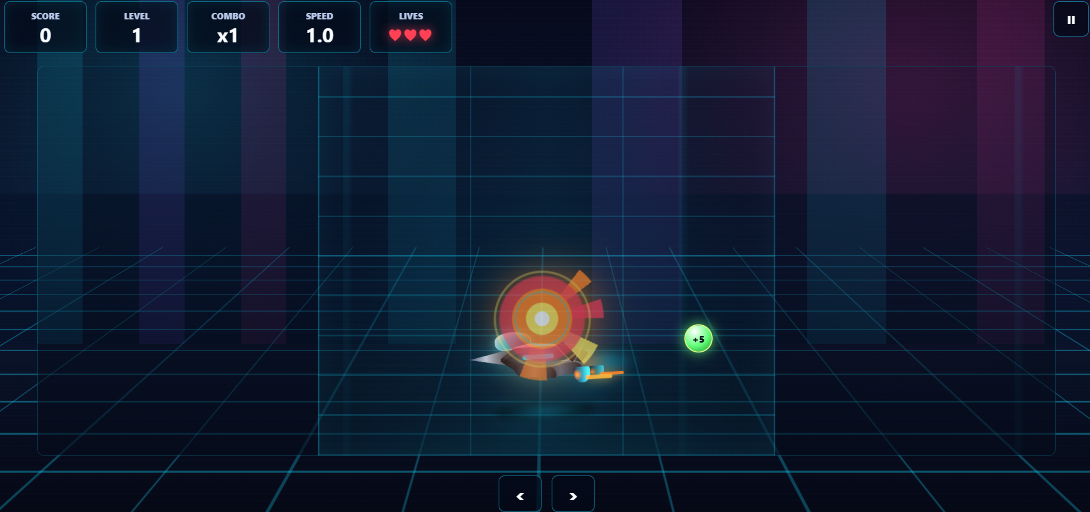
Navigation/flow test | Can the user move through the intended journey? YES | 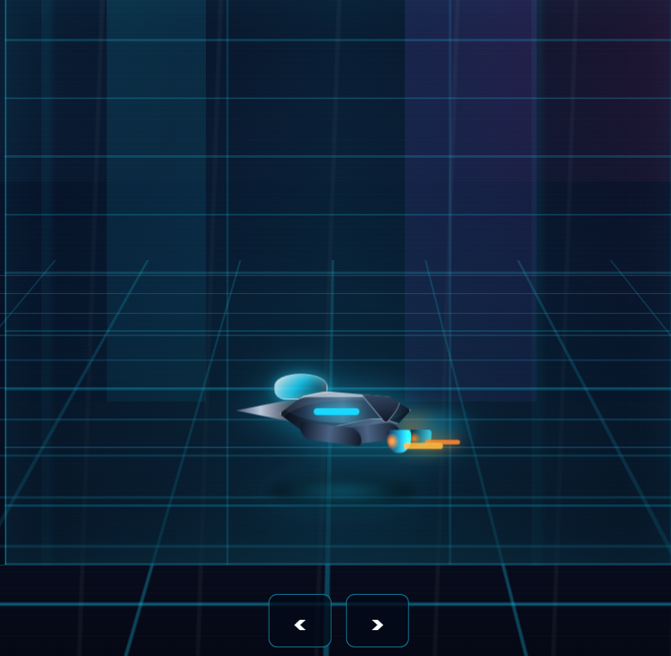  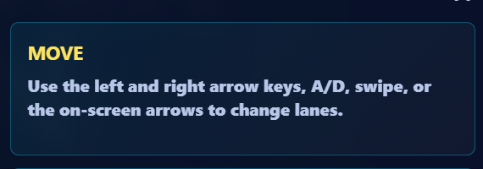
Interaction test | Do buttons, choices, sprites, links, or answers work? YES |   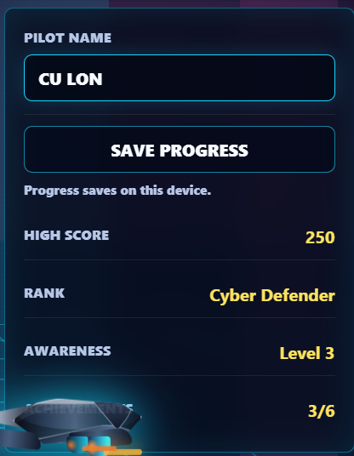  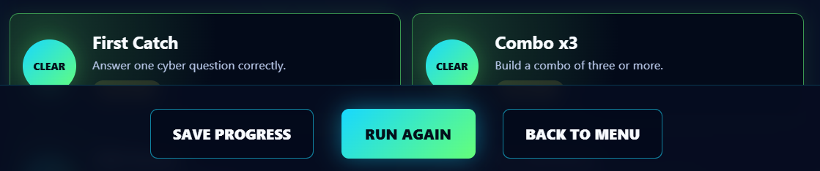  
Feedback test | Does the game explain correct/wrong answers clearly? YES | 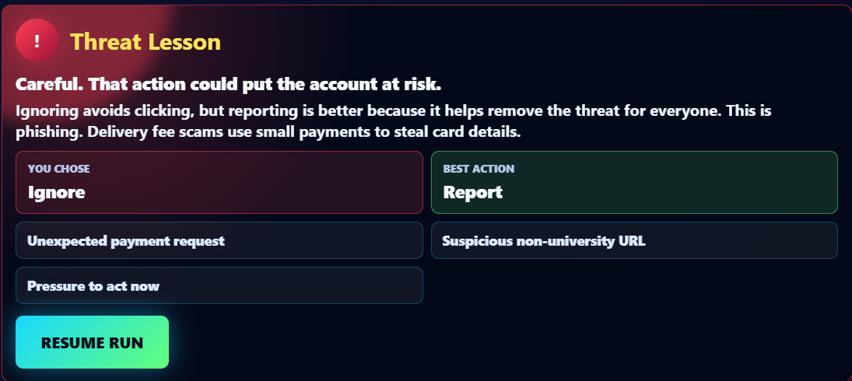  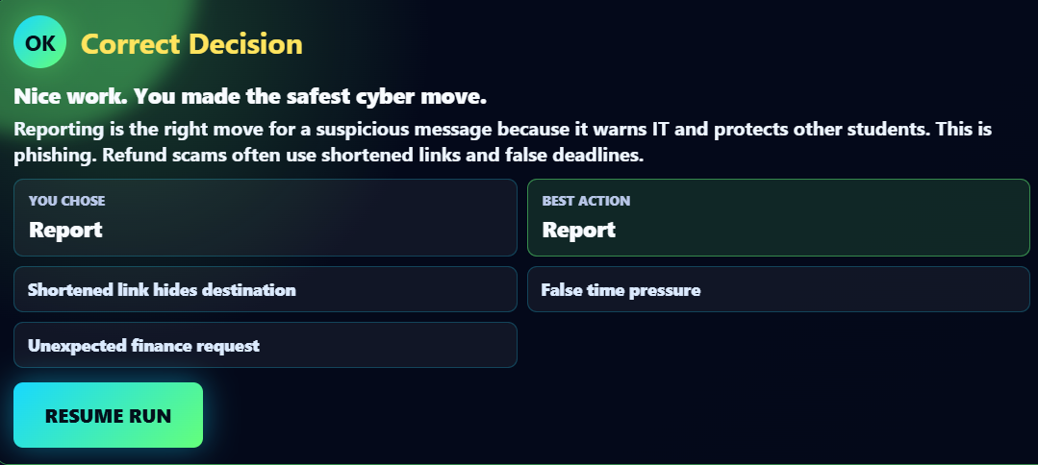
Learning test | Can the tester identify the cyber-safety lesson? YES | 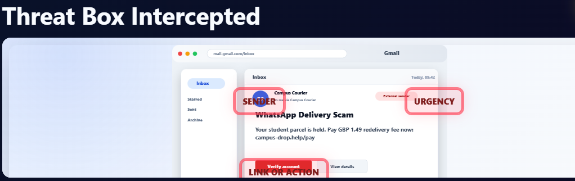  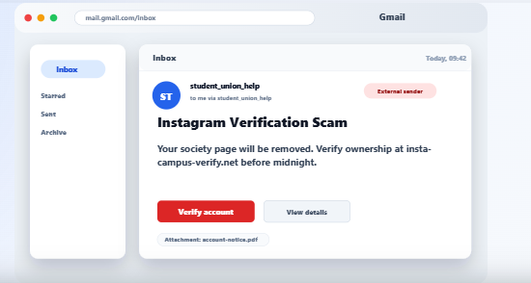  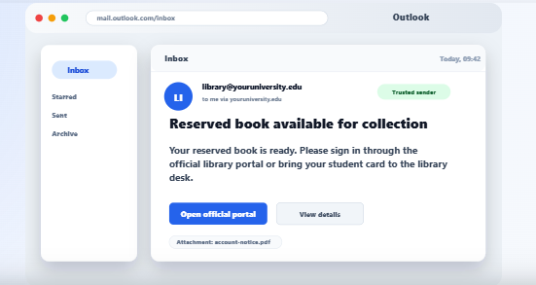
Accessibility test | Is text readable, buttons visible, instructions clear, and design suitable for the target audience? YES | 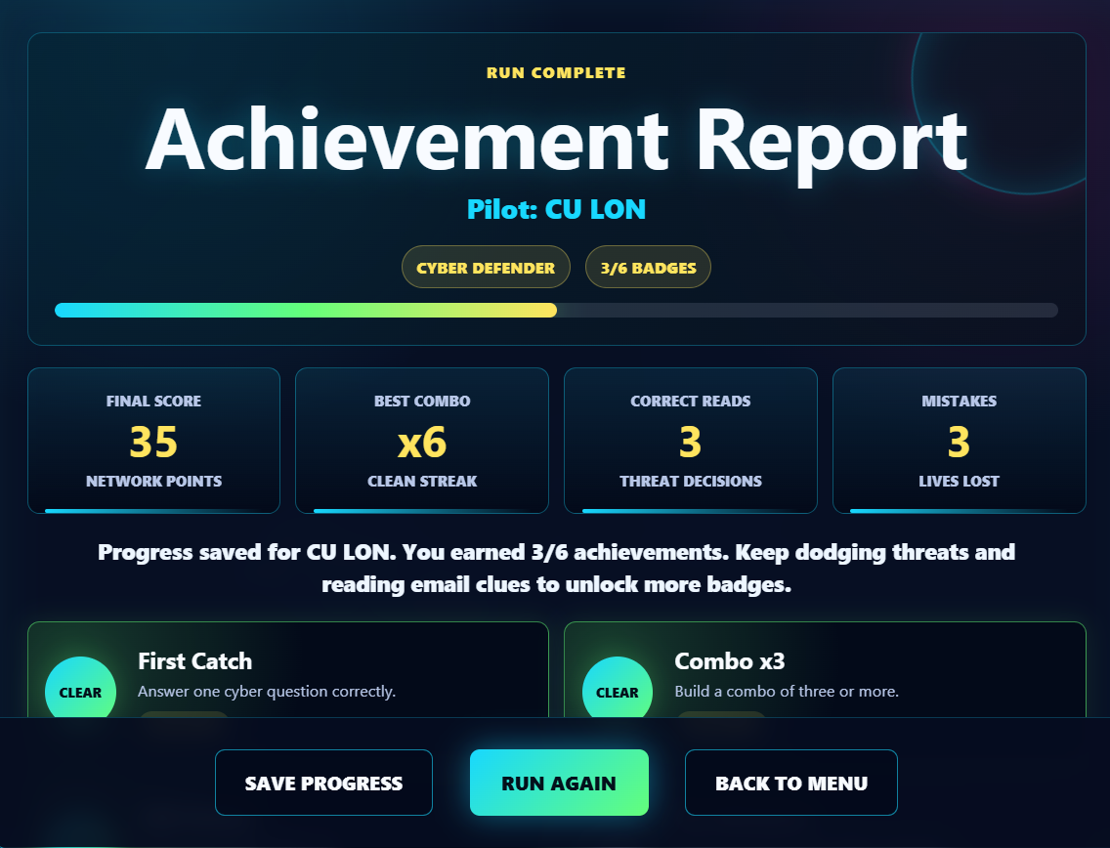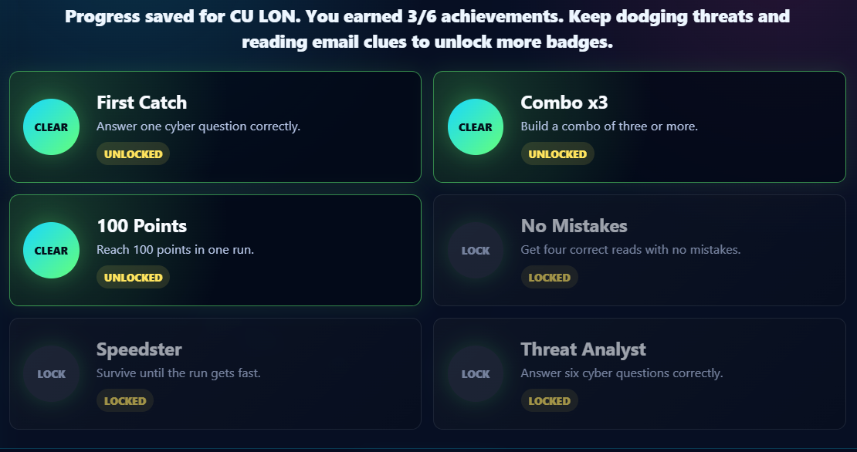
Bug test | What does not work yet? | After saving the progress, unable to see the saved Data.  

